Supplementary Information
Island biogeography on a micro-scale: larger anammox granules not only harbor higher species diversity but also support more functional diversity
Hui Chen^{1,2#}, Tao Liu^{1#}, Jie Li¹, Likai Mao¹, Jun Ye³, Xiaoyu Han⁴, Mike S. M. Jetten⁵, Jianhua Guo¹*
¹ Advanced Water Management Centre, The University of Queensland, St Lucia, Queensland 4072, Australia.
² School of Environmental Science and Engineering, Shandong University, Qingdao, Shandong Province 266237, China
³ Australian Centre for Ecogenomics, The University of Queensland, St Lucia, Queensland 4072, Australia.
⁴ School of Municipal and Environmental Engineering, Harbin Institute of Technology, Harbin，China
⁵ Microbiology, IWWR, Faculty of Science, Radboud University Nijmegen, Heyendaalseweg 135, 6525 AJ Nijmegen, The Netherlands.

#These authors contributed equally to the work
*Corresponding author: Jianhua Guo, Phone: + 61 7 3346 3222; FAX: + 61 7 3365 4726; E-mail: j.guo@awmc.uq.edu.au

The following are included as supporting information for this paper:
number of pages: 13
number of figures: 5
number of tables: 4
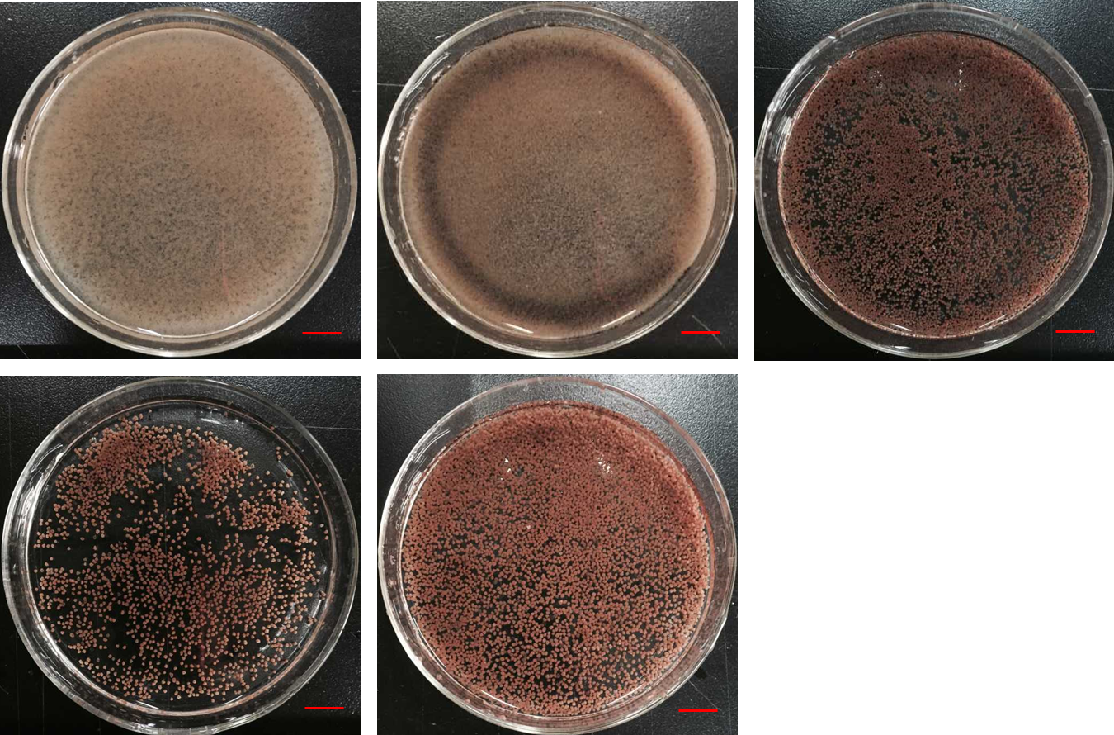
Fig. S1 Macroscopic morphology of PNA granules. A, P1 (< 0.2 mm); B, P2 (0.2-0.5 mm); C, P3 (0.5-0.8 mm); D, P4 (0.8-1.0 mm) and E, P5 (>1.0 mm). Bar = 10 mm.

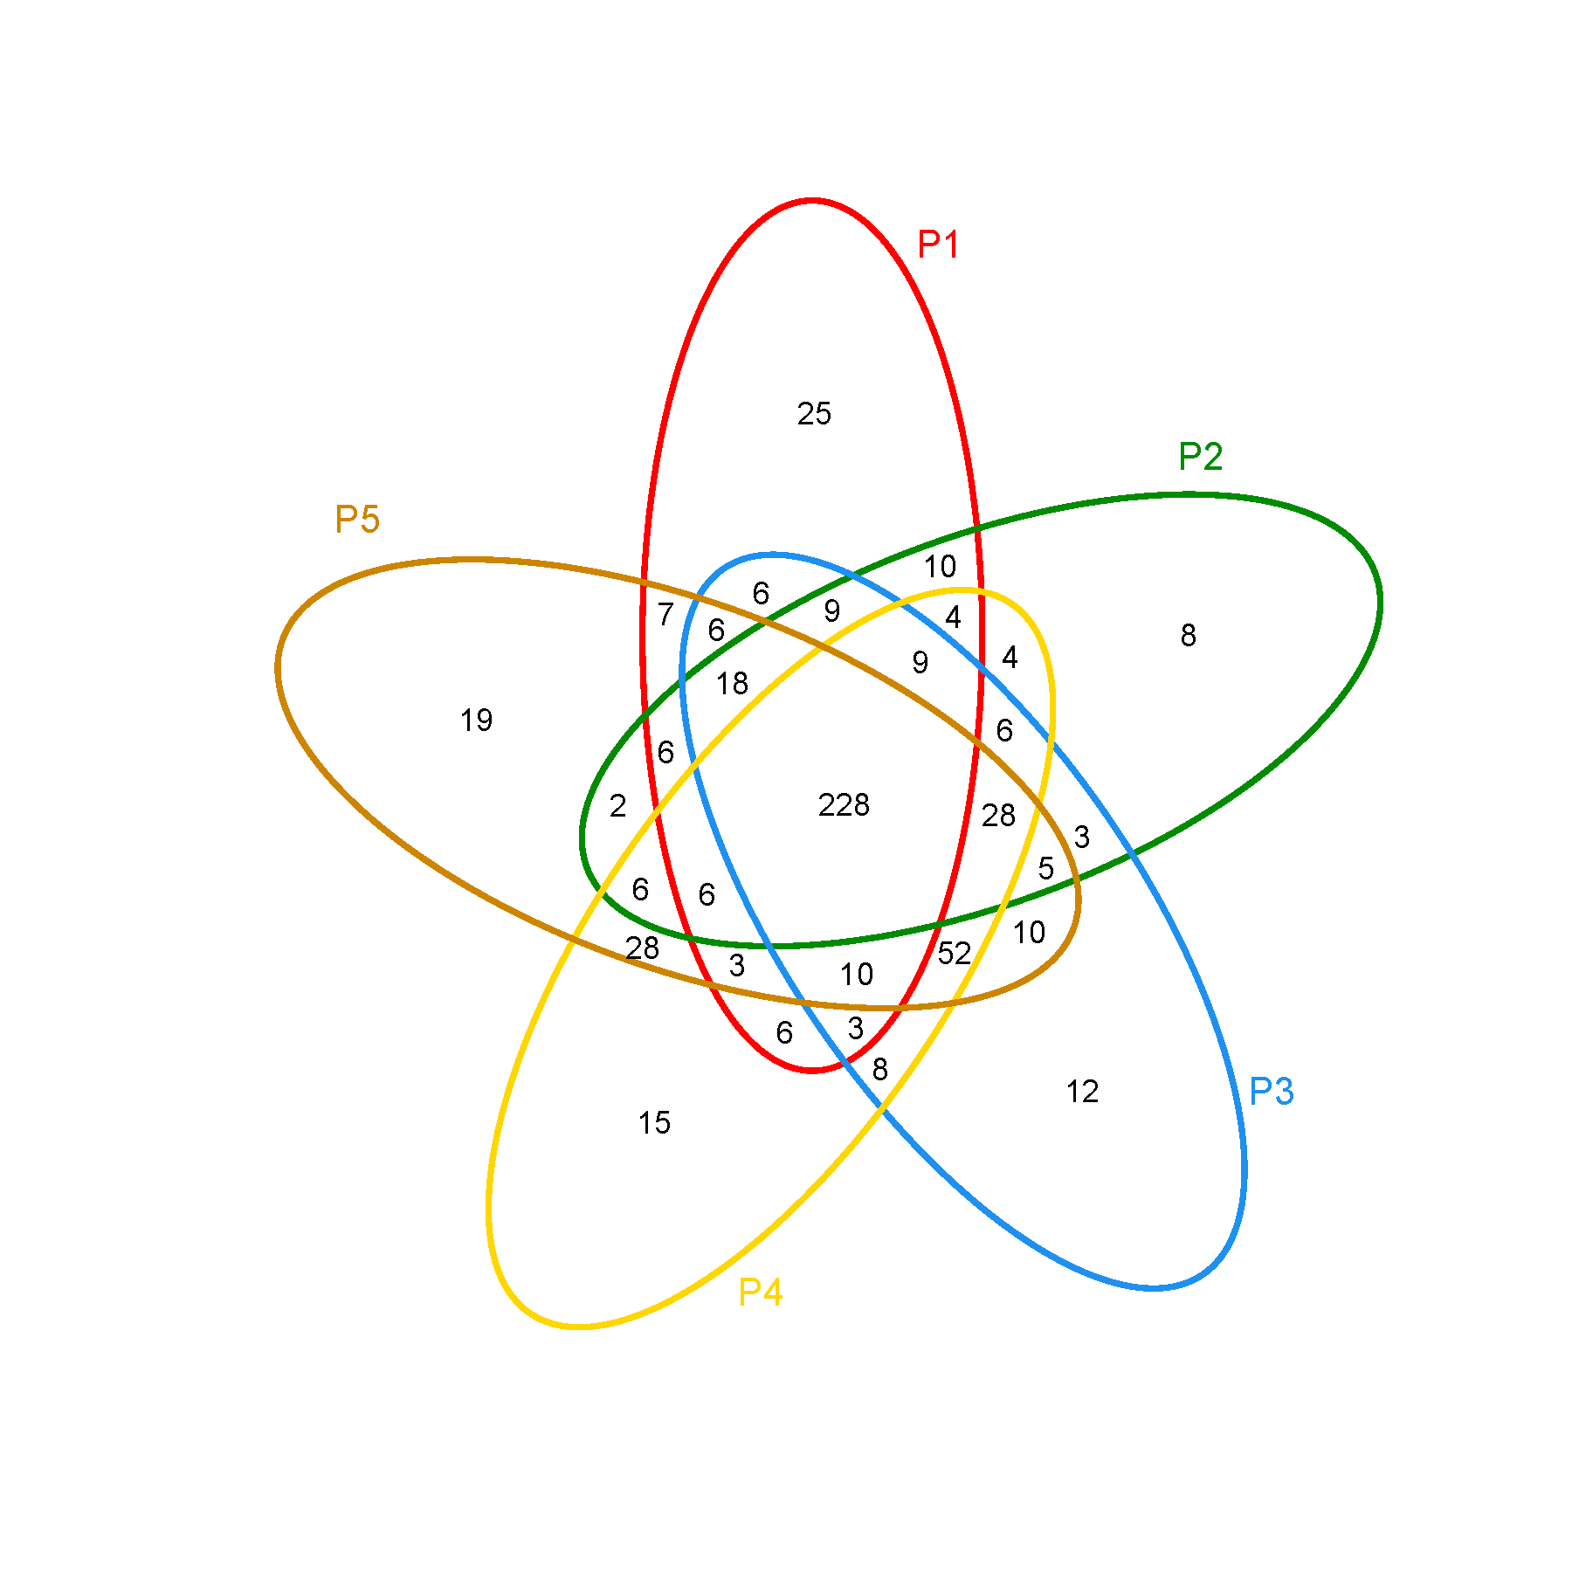
Fig. S2 Venn diagram of granules in five size-fractions based on 16S rRNA gene sequencing data.

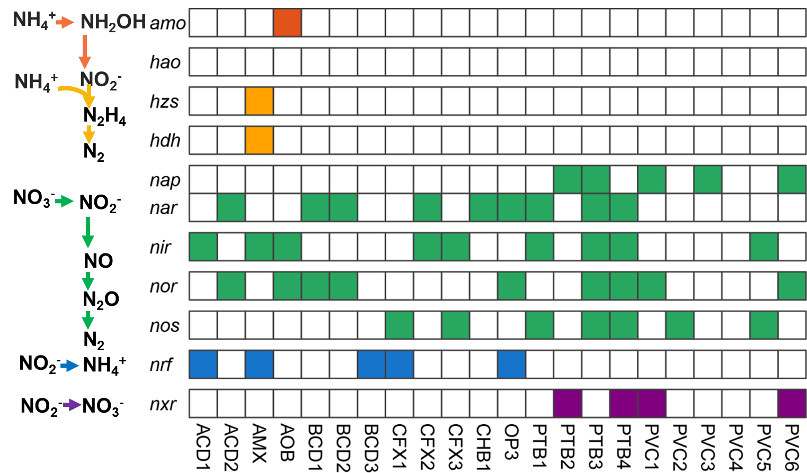

Fig. S3 Nitrogen metabolism genes of 22 metagenome-assembled genomes from anammox granule, gene content based on presence (filled squares) or absence of key genes involved different nitrogen metabolic process. Gene abbreviations: amo ammonia monooxygenase, hao hydroxylamine oxidoreductase, hzs hydrazine synthase, hdh hydrazine dehydrogenase, nap periplasmic nitrate reductase, nar membrane-bound nitrate reductase, nir nitrite reductase, nor cytc dependent nitric oxide reductase, nos nitrous oxide reductase, nrf pentaheme nitrite reductase, nxr, nitrite oxidoreductase

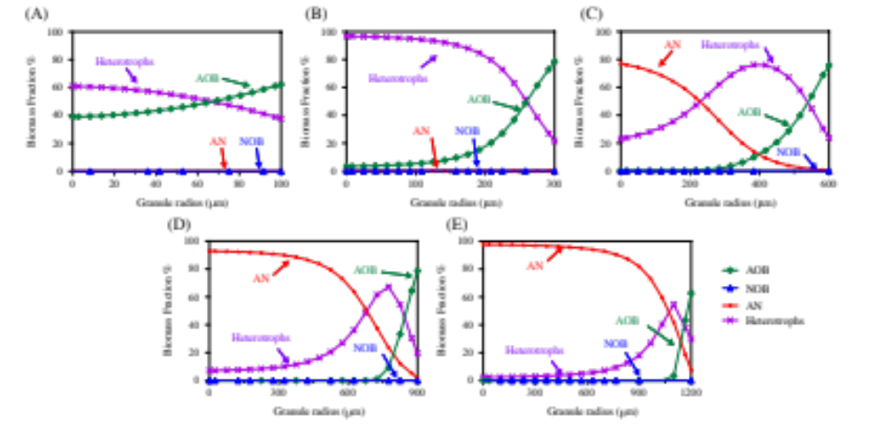
Fig. S4 Model simulation results of one-stage anammox processes: microbial stratification in granules with radius of 0.1 (A), 0.3 (B), 0.6 (C), 0.9 (D), 1.2 (E) mm. Depth zero represents the granule inner layer.

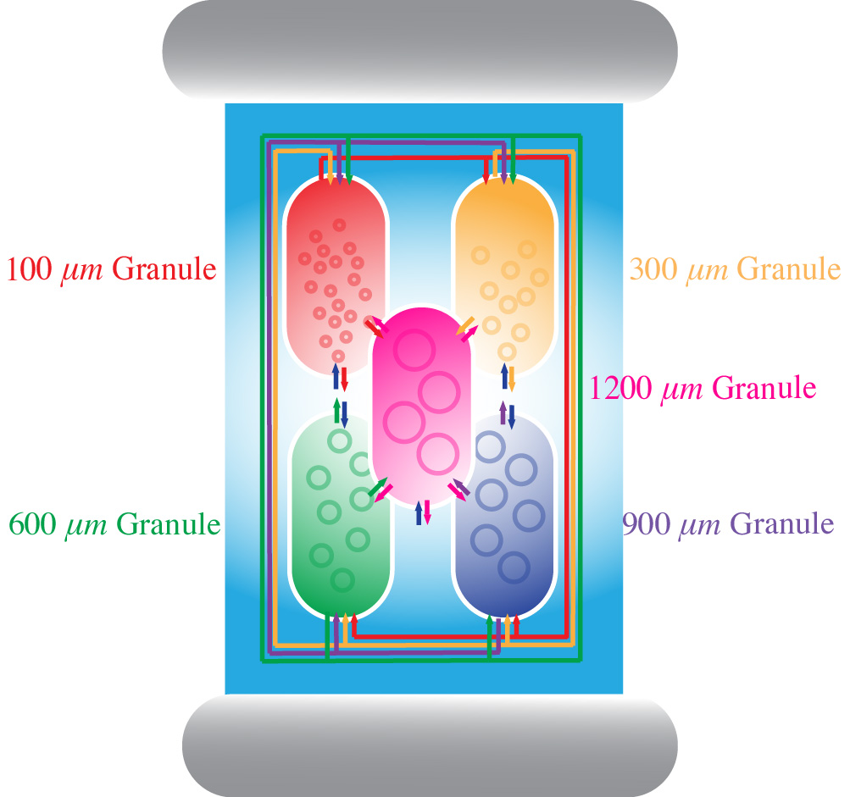
Fig. S5 Schematic for the granule-based reactor integrating granules with five different size (100, 300, 600, 900 and 1200 μm) in Aquasim, which is adapted from Liu et al. (2017). The inflow rate and bulk volume of each chamber were set to be proportional to the amount of biomass.

Table S1 Performance of PN/A reactor during the sampling time
 | COD (mg/L or %) |  |  |  | NH₄⁺-N (mg/L or %) |  |  |  | NO₃⁻-N in effluent (mg/L) | Ammonium Removal Rate (kg N/m³/d) | TN removal rate (kg N/m³/d)
 | Influent | Effluent | Removal efficiency |  | Influent | Effluent | Removal efficiency |  | NO₃⁻-N in effluent (mg/L) | Ammonium Removal Rate (kg N/m³/d) | TN removal rate (kg N/m³/d)
Average | 336 | 93 | 71 |  | 1724 | 149 | 87 |  | 77 | 0.71 | 0.82
S.D. | 116 | 29 | 16 |  | 846 | 124 | 18 |  | 45 | 0.47 | 0.18

Table S2 Relative abundance of major txa across the five size-fractions based on 16S. Numbers in cells indicate the relative abundances.
Phylum | Genus | <0.2 mm | 0.2-0.5 mm | 0.5-0.8 mm | 0.8-1.0 mm | >1.0 mm
Proteobacteria | Nitrosomonas | 33.84 | 17.12 | 9.95 | 6.39 | 5.66
 | Denitratisoma | 3.79 | 3.24 | 4.86 | 8.57 | 6.06
 | Xanthomonadales_uncultured | 0.92 | 0.87 | 1.35 | 4.62 | 2.90
 | Thauera | 0.70 | 1.74 | 1.42 | 1.02 | 0.88
 | DB1-14_norank | 0.82 | 1.10 | 0.67 | 0.58 | 0.64
 | Haliangium | 0.57 | 0.54 | 0.58 | 0.90 | 1.07
 | Deltaproteobacteria_unclassified | 0.05 | 0.14 | 0.56 | 1.16 | 1.62
 | Aquicella | 0.04 | 0.05 | 0.21 | 0.98 | 1.87
Planctomycetes | Candidatus Kuenenia | 0.26 | 0.87 | 5.27 | 7.21 | 9.36
Chloroflexi | Anaerolineaceae_uncultured | 1.72 | 3.71 | 4.49 | 5.69 | 6.78
 | Chloroflexi_uncultured | 4.95 | 3.34 | 2.78 | 1.27 | 1.05
 | Caldilineaceae_uncultured | 0.56 | 0.83 | 0.93 | 1.41 | 1.28
 | TK10_norank | 0.31 | 1.16 | 1.27 | 1.15 | 1.06
Chlorobi | SJA-28_norank | 12.70 | 24.63 | 31.02 | 23.07 | 24.74
 | OPB56_norank | 1.06 | 1.70 | 1.47 | 1.21 | 1.08
 | Ignavibacterium | 0.22 | 0.45 | 0.58 | 1.50 | 0.87
Bacteroidetes | Saprospiraceae_uncultured | 10.63 | 11.10 | 9.97 | 7.63 | 6.62
 | Chitinophagaceae_uncultured | 2.90 | 2.88 | 1.57 | 0.77 | 0.63
 | env.OPS_17_norank | 0.77 | 1.53 | 0.81 | 1.39 | 0.33
 | Bacteroidetes_unclassified | 0.20 | 1.02 | 1.03 | 0.81 | 0.99
Armatimonadetes | Chthonomonadales_norank | 0.41 | 1.55 | 1.49 | 0.94 | 0.46
Acidobacteria | Bryobacter | 0.01 | 0.04 | 0.48 | 1.39 | 1.60
WS6 | WS6_norank | 0.25 | 0.49 | 0.81 | 2.91 | 3.63
Verrucomicrobia | LD29_norank | 1.55 | 2.08 | 0.88 | 0.23 | 0.16
Spirochaetae | Leptospira | 1.44 | 1.09 | 0.60 | 0.33 | 0.45
SHA-109 | SHA-109_norank | 5.99 | 2.75 | 1.79 | 1.02 | 0.96
Hydrogenedentes | Hydrogenedentes_norank | 0.46 | 1.27 | 0.73 | 0.44 | 0.30

Table S3 Size distribution of PN/A granular sludge
Granule size class (mm) | Relative abundance (% VSS) | Arithmetic mean diameter d_{mar} (mm) | Volume (mm³)
<0.2 | 14.8 | 0.15 | 0.0018
0.2-0.5 | 36.7 | 0.35 | 0.0224
0.5-0.8 | 22.6 | 0.65 | 0.1437
0.8-1.0 | 17.4 | 0.9 | 0.3815
>1.0 | 8.5 | 1.5 | 1.7663

Table S4 Stoichiometric matrix for the model.
Variable  Process | S_{O2}  O₂ | S_{S}  COD | S_{NH4}  N | S_{NO2}  N | S_{NO3}  N | S_{N2}  N | X_{S}  COD | X_{AOB}  COD | X_{NOB}  COD | X_{AN}  COD | X_{H}  COD | X_{AN}  COD
1. Hydrolysis  $k_{H}\frac{{X_{S}}/{X_{H}}}{K_{X}+{X_{S}}/{X_{H}}}X_{H}$ |  | 1 |  |  |  |  | -1
2. Growth of AOB$$μ_{AOB}\frac{S_{O2}}{K_{O2}^{AOB}+S_{O2}}\frac{S_{NH4}}{K_{NH4}^{AOB}+S_{NH4}}X_{AOB}$$ | $$-\frac{3.43-Y_{AOB}}{Y_{AOB}}$$ |  | $${-i}_{NBM}-1/Y_{AOB}$$ | $$\frac{1}{Y_{AOB}}$$ |  |  |  | 1
3. Aerobic endogenous respiration of AOB  $$b_{AOB}η_{AOB}\frac{K_{O2}^{AOB}}{K_{O2}^{AOB}+S_{O2}}\frac{S_{NO3}}{K_{NO3}^{AOB}+S_{NO3}}X_{AOB}$$ | $$-(1-f_{I})$$ |  | $$i_{NBM}-i_{NXI}f_{I}$$ |  |  |  | $$1-f_{I}$$ | -1 |  |  |  | $$f_{I}$$
4. Anoxic endogenous respiration of AOB  $$b_{AOB}η_{AOB}\frac{K_{O2}^{AOB}}{K_{O2}^{AOB}+S_{O2}}\frac{S_{NO3}}{K_{NO3}^{AOB}+S_{NO3}}X_{AOB}$$ |  |  | $$i_{NBM}-i_{NXI}f_{I}$$ |  | $$-\frac{1-f_{I}}{2.86}$$ | $$\frac{1-f_{I}}{2.86}$$ | $$1-f_{I}$$ | -1 |  |  |  | $$f_{I}$$
5. Growth of NOB  $$μ_{NOB}\frac{S_{O2}}{K_{O2}^{NOB}+S_{O2}}\frac{S_{NO2}}{K_{NO2}^{NOB}+S_{NO2}}X_{NOB}$$ | $$-\frac{1.14-Y_{NOB}}{Y_{NOB}}$$ |  | $$-i_{NBM}$$ | $$-\frac{1}{Y_{NOB}}$$ | $$\frac{1}{Y_{NOB}}$$ |  |  |  | 1
6. Aerobic endogenous respiration of NOB  $$b_{NOB}\frac{S_{O2}}{K_{O2}^{NOB}+S_{O2}}X_{NOB}$$ | $$-(1-f_{I})$$ |  | $$i_{NBM}-i_{NXI}f_{I}$$ |  |  |  | $$1-f_{I}$$ |  | -1 |  |  | $$f_{I}$$
7. Anoxic endogenous respiration of NOB  $$b_{NOB}η_{NOB}\frac{K_{O2}^{NOB}}{K_{O2}^{NOB}+S_{O2}}\frac{S_{NO3}}{K_{NO3}^{NOB}+S_{NO3}}X_{NOB}$$ |  |  | $$i_{NBM}-i_{NXI}f_{I}$$ |  | $$-\frac{1-f_{I}}{2.86}$$ | $$\frac{1-f_{I}}{2.86}$$ | $$1-f_{I}$$ |  | -1 |  |  | $$f_{I}$$
8. Growth of Anammox  $$μ_{AN}\frac{K_{O2}^{AN}}{K_{O2}^{AN}+S_{O2}}\frac{S_{NH4}}{K_{NH4}^{AN}+S_{NH4}}\frac{S_{NO2}}{K_{NO2}^{AN}+S_{NO2}}X_{AN}$$ |  |  | $${-i}_{NBM}-1/Y_{AN}$$ | $$-\frac{1}{Y_{AN}}-\frac{1}{1.14}$$ | $$-\frac{1}{1.14}$$ | $$\frac{2}{Y_{AN}}$$ |  |  |  | 1
9. Aerobic endogenous respiration of Anammox  $$b_{AN}\frac{S_{O2}}{K_{O2}^{AN}+S_{O2}}X_{AN}$$ | $$-(1-f_{I})$$ |  | $$i_{NBM}-i_{NXI}f_{I}$$ |  |  |  | $$1-f_{I}$$ |  |  | -1 |  | $$f_{I}$$
10. Anoxic endogenous respiration of Anammox  $$b_{AN}η_{AN}\frac{K_{O2}^{AN}}{K_{O2}^{AN}+S_{O2}}\frac{S_{NO3}}{K_{NO3}^{AN}+S_{NO3}}X_{AN}$$ |  |  | $$i_{NBM}-i_{NXI}f_{I}$$ |  | $$-\frac{1-f_{I}}{2.86}$$ | $$\frac{1-f_{I}}{2.86}$$ | $$1-f_{I}$$ |  |  | -1 |  | $$f_{I}$$
11. Aerobic growth of X_{H}  $$μ_{H}\frac{S_{O2}}{K_{O2}^{H}+S_{O2}}\frac{S_{S}}{K_{S}+S_{S}}X_{H}$$ | $$-\frac{1-Y_{H,O2}}{Y_{H,O2}}$$ | $$-\frac{1}{Y_{H,O2}}$$ | $$-i_{NBM}$$ |  |  |  |  |  |  |  | 1
12. Anoxic growth of X_{H} using nitrite  $$μ_{H}η_{H}\frac{K_{O2}^{H}}{K_{O2}^{H}+S_{O2}}\frac{S_{NO2}}{K_{NO2}^{H}+S_{NO2}}\frac{S_{S}}{K_{S}+S_{S}}X_{H}$$ |  | $$-\frac{1}{Y_{H,NO}}$$ | $$-i_{NBM}$$ | $$-\frac{(1-Y_{H,NO})}{1.71Y_{H,NO}}$$ |  | $$\frac{(1-Y_{H,NO})}{1.71Y_{H,NO}}$$ |  |  |  |  | 1
13. Anoxic growth of X_{H} using nitrate  $$μ_{H}η_{H}\frac{K_{O2}^{H}}{K_{O2}^{H}+S_{O2}}\frac{S_{NO3}}{K_{NO3}^{H}+S_{NO3}}\frac{S_{S}}{K_{S}+S_{S}}X_{H}$$ |  | $$-\frac{1}{Y_{H,NO}}$$ | $$-i_{NBM}$$ |  | $$-\frac{(1-Y_{H,NO})}{2.86Y_{H,NO}}$$ | $$\frac{(1-Y_{H,NO})}{2.86Y_{H,NO}}$$ |  |  |  |  | 1
14. Aerobic endogenous respiration of X_{H}  $$b_{H}\frac{S_{O2}}{K_{O2}^{H}+S_{O2}}X_{H}$$ | $$-(1-f_{I})$$ |  | $$i_{NBM}-i_{NXI}f_{I}$$ |  |  |  | $$1-f_{I}$$ |  |  |  | -1 | $$f_{I}$$
15. Anoxic endogenous respiration of X_{H}  $$b_{H}η_{H}\frac{K_{O2}^{H}}{K_{O2}^{H}+S_{O2}}\frac{S_{NO3}}{K_{NO3}^{H}+S_{NO3}}X_{H}$$ |  |  | $$i_{NBM}-i_{NXI}f_{I}$$ |  | $$-\frac{1-f_{I}}{2.86}$$ | $$\frac{1-f_{I}}{2.86}$$ | $$1-f_{I}$$ |  |  |  | -1 | $$f_{I}$$
* The definition and values of the kinetic and stoichiometric parameters above can be found in Liu et al., (2017).

Reference
Liu, T., Ma, B., Chen, X., Ni, B.-J., Peng, Y., and Guo, J. (2017) Evaluation of mainstream nitrogen removal by simultaneous partial nitrification, anammox and denitrification (SNAD) process in a granule-based reactor. Chemical Engineering Journal 327: 973-981.

